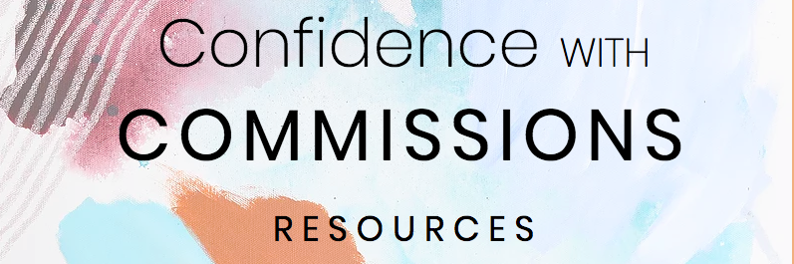

LINKS:

Canva
For easy and pretty PDF creation

Creative Pep Talk Episode #176: How to Approach Those You Want to Work With
Fun and informative podcast episode for those interested in reaching out to brands and companies for potential commissions and/or licensing

17 Hats
Online program I use to easily create and send contracts to be digitally signed

Google Forms and Typeform
Both easy to use for creating surveys.

If you want to check out the exact links to my surveys, you can do so here for the assessment form and here for the feedback survey.

For payments:

I typically use Paypal. I find it easy to set up an account and then send people a paypal.me button for the amounts that are due.
You can send a link for the amount you are requesting which will look like:
www.paypal.me/[your paypal username]/[numer of the amount you are requesting]

For payment plans I like to use Moonclerk

Below are the text versions of the agreements in your PDF guide:

Commissioned Art Agreement

This agreement is made on April 9, 2018 by and between:
Name: Devon Walz (Artist)
Email: devonleewalz@gmail.com
and
Name: Jane Adams (Collector)
Email: Janeadams@gmail.com

The parties agree as follows:
- The Project: Collector is commissioning one custom piece of abstract art on 36 x 36 in. canvas in accordance with the stylistic desires of the Collector. The artwork will have a gallery wire installed and will either be signed on the front or back depending on the final design.
- Deliverables: Upon completion of the project, and once the of second and final payment is made, the Artist will ship the Collector the original artwork within 7 business days via UPS in a professionally packed box.
- Right of Refusal: It is the intent of this agreement that the Artist create artworks for the Collector that the Collector will love. If the Collector is unsatisfied at the end of the project, the Collector may refuse the final piece. In that case, the Artist will retain the refused artwork and the nonrefundable first payment, free of any claims or interests of the Collector and the Collector will owe no additional fees to the Artist.
- Copyright: Artist reserves the common-law copyright to all works commissioned by Collector that are created by the Artist, including all reproduction rights and the right to claim statutory copyright.
- Payment Amounts: The total cost of this project is $900 USD plus shipping. A shipping estimate will be given once Collector's shipping address is provided.
- Payment Terms: The Collector agrees to pay a non-refundable deposit of $450 USD at the start of the project and before any creative production work has begun and $450 plus the cost of shipping at the end of the project.

IN WITNESS WHEREOF the parties hereto have executed this Agreement on the day and year written above.

Commission and Licensing Agreement For Album Cover Art

This agreement is made on March 8, 2018 by and between:
Name: Devon Walz (Artist)
Email: devonleewalz@gmail.com
and
Name: Jamie Adams (Collector)
Email: Jameadams@gmail.com
The parties agree as follows:
- The Project: Collector is commissioning one custom piece of abstract art to be used for the cover of her album.
- Deliverables: Upon completion of the project, and once the of second and final payment is made, the Artist will send the Collector a high resolution photo of the artwork (300 dpi), as well as mail the original artwork to the Collector within 7 business days.
- Right of Refusal: It is the intent of this contract that the Artist create artworks for the Collector that the Collector will purchase. If the Collector is unsatisfied at the end of the project, the Collector may refuse the final piece. In that case, the Artist will retain the refused artwork and the nonrefundable first payment, free of any claims or interests of the Collector and the Collector will owe no additional fees to the Artist.
- Usage: The Collector is permitted to use the commissioned artwork for printing on Album/CD covers and online representation of the album only. If additional merchandise is to be printed with the image, a new agreement will be made between the Collector and Artist.
- Credit: The Artist's name will remain clearly legible on all printed items and credit will be given where the digital item appears online.
- Copyright: Artist reserves the common-law copyright to all works commissioned by Collector that are created by the Artist, including all reproduction rights and the right to claim statutory copyright.
- Modifications to the artwork: Collector is permitted to make digital alterations to the artwork (i.e. adding in a photograph) so long as those alterations and final image are approved by the Artist.
- Payment Amounts: The total cost of this project is $XXX plus shipping.
- Payment Terms: The Collector agrees to pay a non-refundable deposit of $XXX at the start of the project and before any work has began and $XXX plus the cost of shipping at the end of the project. A shipping quote will be given once the size and surface of the original piece has been determined.

IN WITNESS WHEREOF the parties hereto have executed this Agreement on the day and year written above.
*please note that I am not a lawyer and the above recommendations should not be taken as legal advice. I always recommend doing your own research or consulting a lawyer if you want to ensure that you are legally protected.

